

To: Professor Osama Alshaykh and Professor Alan Pisano

From: Caroline Jones, Sneha Pradhan, Michael Haley, Tanatsigwa Hungwe, and Zehua (Harry) Zhao

Team: 1

Date: 02/17/17

Subject: **Luminesense System Second Deliverable Test Report**

**___________________________________________________________________________________________**



1. **Project Objective**

1.1 Team Luminesense seeks to revolutionize the way that people interact with lighting fixtures in rooms. The project’s primary motivation is to provide an intelligent, gesture based lighting system that provides customizable, convenient, and energy efficient control over these fixtures.

**2.0 Test Objective and Significance**

2.1 The overall objective of this test was to build upon the foundation established in the previous deliverable. That deliverable showcased the communication loop amongst the components of the system. The second deliverable focused on developing various system components needed for added features and functionality. The system components developed and tested included the following: light modulation, gestures, occupancy sensing, and the web application. All these developed components were key deliverables required by the client. The various testing arrangements described below prove the validity of the developed concepts and guarantee successful interactions between the user and the Luminesense system. Ultimately, most of these concepts will be designed and developed in additional iterations of the system design.

2.2 **Light Modulation**

The “luminaire” is a device provided by the client. It is a powerful light emitting diode which emits a light code that is uniquely identifiable by its frequency. The luminaire is driven by a Particle Photon. The proposed Luminesense system design will have an array of 16 luminaires and in order to interact with them, the system needs to be able to distinguish amongst them. To do so, the system must be able to sample and decode these light codes. For this purpose, a photodiode amplifier circuit was attached to the Arduino 101. The following arrangement models the basic functionality of the wearable device: The photodiode samples analog light signals, and subsequently, Arduino determines the frequency of the light signals and hence, determines the light chosen. Testing this component was vital to ensure that the wearable could precisely receive and determine light ID’s in order to ensure an accurate and satisfying user experience. Shown below in Figure 1 is the photodiode amplifier circuit.

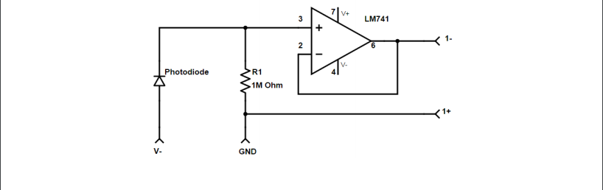

*Figure 1: Photodiode Amplifier circuit*

2.3 **Wearable Gestures**

The wearable is one of the key part of the project. It is the product that their user will be directly interfacing with. In the first deliverable, we have two gestures that turned the lights on and off. In this deliverable, we added more gestures to be able to control the colors of the light. This is a step towards the gesture library that the client wanted us to have. Increasing the number of gestures, the wearable can perform enhances the features of our product and makes the product more desirable.

2.4 **Web Application - Gestures**

The web application is one of the key requirements put forward by the client. The client wanted us to build a user interface to control the system as well as get historic data regarding energy consumption. The web application was created using a Bootstrap template. The significance of controlling the Luminesense light system via a web application is that it provides an alternative way to control the light fixtures. For instance, if the battery of the wearable has finished, or if the wearable is not functional, then a user can still customize their light fixtures accordingly. This adds a user interface which makes the system more appealing to users.

2.5 **Web Application - Energy Savings**

The web application serves as a tool for a user to be able to interact with and monitor their system. One major component of this hub that the client requested is the ability for a user to track their energy consumption, including the energy and money that they are saving by using the system. The web application is developed in JavaScript and deployed via Heroku. A PostgreSQL database that contains energy data is also hosted on Heroku. The deployment of the web site and the integration of the database is a significant step towards having a fully functional user portal, because now that the server portion of the website is completed, all work can be put into the frontend of the website and displaying the necessary user information. The main purpose of this test is to show the live web application and to demonstrate successful queries from the PostgreSQL database.

2.6 **Wearable Design**

The focus of the wearable design is to test the safety and the battery life on the Arduino 101 board. The battery should prevent the possibility of short circuiting when the voltage from the battery is too low. Additionally, the battery should provide a stable current for the Arduino 101 for a reasonable period of time after fully charged. All the tests were ran with respect to the Arduino 101.

2.7 **Adaptive Mode**

An additional requirement set by the client is a system that will respond and interact with users

even when a wearable is not present. The solution for this is an “adaptive mode” - that detects the

presence (or absence) of occupants in the environment and updates the luminaires accordingly.

Adaptive mode is invoked using twelve single pixel sensors (provided by client) driven by a

Raspberry Pi. In order to successfully implement the adaptive mode, the thermal data collected

by these sensors needs to be sampled and analyzed appropriately. This deliverable showed the

ability to detect real time updates of the single pixel readings.

2.8 **Luminaire Controls**

An additional deliverable is the ability to display advanced control over the luminaires. The client desires additional features such as brilliance control (brighten, dimmen) as well as color temperature control (red, blue, green light component manipulation). The luminaire is driven by a Particle Photon. The Photon is responsible for receiving and processing relevant commands. Testing this component was crucial to confirm that the Photon could clearly receive additional command data via Wi-Fi and cause an appropriate change to the state of the luminaire (in this case, brighten, dimmen, and adjust the red, blue and green light components. The photon design schematic is shown below in Figure 2.

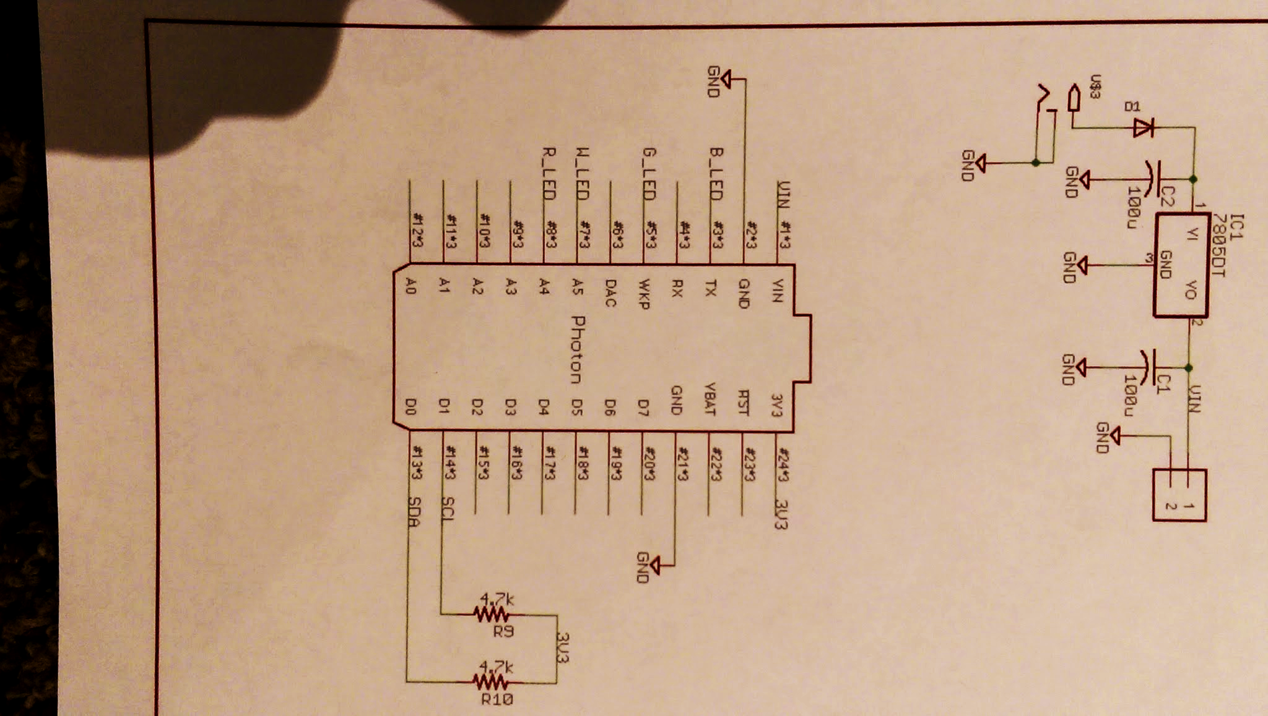

*Figure 2: Photon schematic*

2.9 **Latency Determination**

The determination of the latency is really important since it could negatively affect the product experience for potential users. The delay occurs between the gesture command and luminaire response. It is meaningful and imperative that all observable bottlenecks are found in order to eliminate them in the near future. The quality of the entire project will significantly improve once the latency is completely eliminated or reduced to an acceptable and negligible state.

**3.0 Equipment and Setup**

3.1 **Overall Arrangement**

The entire arrangement of components remained the same as the first deliverable. The setup is shown in Figure 2.

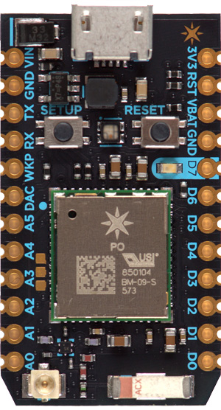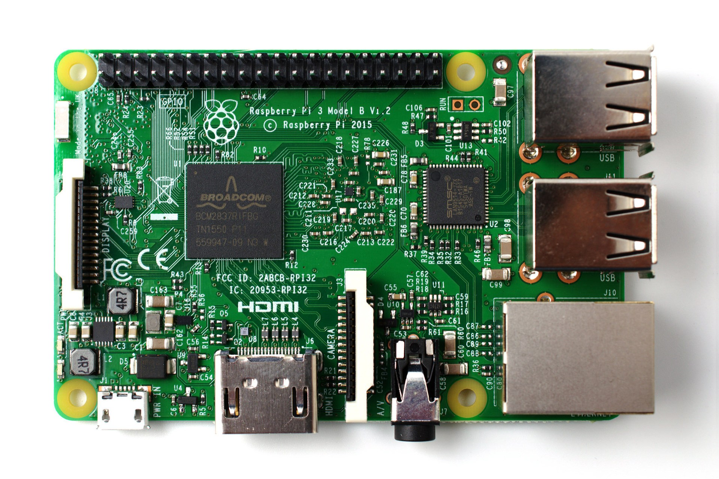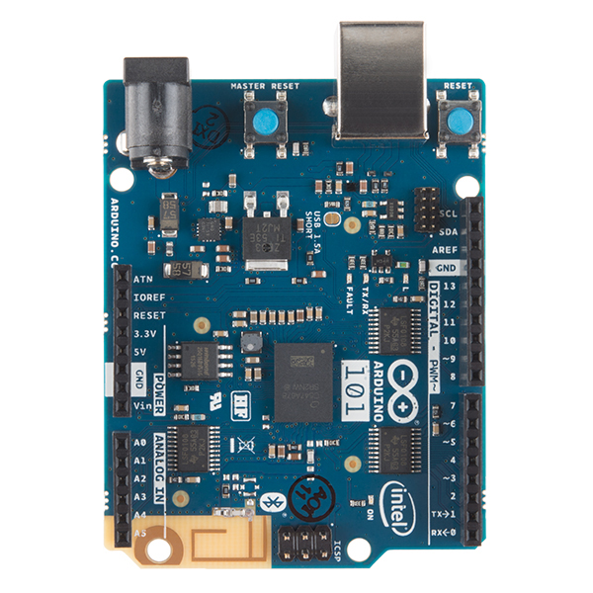

*Figure 3: The Communication Loop*

3.2 **Light Modulation**

Utilizing the Arduino IDE, flash the *Luminaire_FFT.ino* code onto the Arduino 101. This code reads analog input from the photodiode connected to the Arduino’s A0 port. The readings from the photodiode are then aggregated to determine the frequency of the light source using Fast Fourier Transforms (FFT). This involves dividing the sample rate of the ADC into 128 bins/bands of frequency to pinpoint the amplitudes of sampled light (The highest amplitude indicating the light source being observed by the system). Using mathematical operations, the frequency is determined by multiplying the sampling rate by the bin number. The following method is provided by the FFT3 Arduino Library. Using the oscilloscope and the Serial Monitor, the frequency of the light source is then monitored for verification.

3.3 **Wearable Gestures**

To test the functionality of the Arduino 101, wearable_code_v1.ino was uploaded and run on the Arduino 101. Most of the structure of the Arduino 101 code has not changed since the first deliverable. The Arduino 101’s positional data is collected via the built in Gyroscope, Accelerometer as well as the Magnetometer. The algorithm sets the IMU sample rate to 25 Hz, collects raw accelerometer and gyroscope readings in the x, y, and z directions and finally converts the raw data to angular velocity and acceleration values. This data helps determine the board’s orientation. 3 separate gestures were added to change the light from white light to RGB (Red, Green and Blue). The light ID and the orientation data was then sent to the Raspberry Pi via Bluetooth Low Energy, dependent on the status of the state machine (for example, there are is no need to send two “on” commands in a row to the same light). The validity of the orientation data, and hence, the Arduino’s functionality is determined by comparing the data received by the Raspberry Pi and the data printed on the Serial monitor.

3.4 **Web Application - Gestures**

The Web Application was made with the help of Bootstrap. Bootstrap takes care of the underlying designs and responsiveness, that makes working on the front end quicker and efficient. For the gestures, we created a gesture table as a reference for the user. In the future, we plan to make it editable, such that, the user can choose what the he or she wants their gesture to be for the corresponding action. The second part of the Web application: Gestures, gives the user the ability to control the light fixtures via the web interface. This is done by providing various buttons for the user to work with. The on-off buttons will be in the shape of the switch and they will turn the lights on or off. We plan to have a color wheel to control the colors of the lights. There well be an option to brighten and dim the light fixtures as well. The front end as well as the back end for this portion is at a primitive stage. However, it will be ready very soon.

3.5 **Web Application - Energy Savings**

The web application is made up of a few components, which include the Javascript code, the HTML and CSS code, the PostgreSQL database, and the Heroku repository. The node.js, HTML, and CSS were initially set up using bootstrap, an open source project that provides powerful tools for frontend development. We utilized this library in order to quickly show pertinent information to the user and to be able to focus mainly on method of gathering information to be displayed. The Heroku hosting was done by pushing the code directory, stored locally on a laptop, to a Heroku repository. Every time the code is pushed to this repository, the website is updated. The PostgreSQL contains one table called “time” with two columns: a type timestamp column called “timing”, and a type integer column called “lightson,” For now the columns are filled with dummy data for the purpose of testing, but in the future the Raspberry Pi will populate these columns with a timestamp and the number of lights on at that time. When the website is loaded, it queries this table and performs a calculation to determine the average wattage used that day. Each luminaire has a wattage of 12, so it is a simple calculation using the timestamps and number of luminaires on to determine the power consumption for a specified period of time, in this case 24 hours. One can confirm the validity of this test by observing the population of the graph with the dummy data as well as by examining the Heroku logs to see the successful connection to the PostgreSQL database.

3.6 **Wearable Design**

In order to make the battery shield operate with others part of the system, the Arduino code has to be burned onto the Arduino board without the battery shield attached first. After the code is successfully burned onto the board, disconnect the wire cable that connects the Arduino to PC. Turn off the battery switch on the battery. Then attach the battery board to the Arduino board properly. Ensure that all the pins on the battery shield are correctly connected to the pins on the Arduino. Finally, turn on the battery and use the Arduino to gesture and control the luminaires accordingly.

3.7 **Adaptive Mode**

The adaptive mode is made possible by the twelve single pixel sensors which scan the room and each produce values for “blue”, “green”, “red”, and “white”. A combination of these values gives the thermal “status” for a specific area in the room, which will change with the presence of occupants and differences in lighting. The single pixel sensors are driven by a Raspberry Pi, which polls them for a certain time duration to obtain the RGB information. An MQTT broker is used to establish a communication protocol between the local machine and the Raspberry Pi’s network. A java program is then used on a local machine to record sensor readings and saves them to a .txt file.

3.8 **Luminaire Controls**

The Photon and luminaire functionality is determined by sending commands from a PC via a Particle API call to one of its functions (via Wi-fi). The luminaire’s RGBW leads are connected to the A4, WKP, TX, and A5 ports of the Photon. The Photon contains functions *luminesense_disco.ino* (RGBW manipulation), *luminesense_brighter.ino* (brilliance increase), and *luminesense_dimmer.ino* (brilliance decrease), which are responsible for changing the state of the luminaire. The validity of the Photon’s functionality and the commands is tested by observing the state of the luminaire (“on” or “off”) and the CLI (Command Line Interface) call outputs printed on the Terminal window.

3.9 **Latency Determination**

Declare the time library on the Arduino with

#include <CurieTime.h>

This is the unique time library for Arduino Intel Curie. Then call the following functions in order to print the time in order of “hour:minute:second”:

Serial.print("Ok, Time = ");

Serial.print(hour());

Serial.print(':');

Serial.print(minute());

Serial.print(':');

Serial.print(second());

This will automatically print out the time every five seconds if there is no new IMU data detected. When a new gesture command is detected (new IMU data received), it will print out the time associated with the gesture detected immediately. By comparing the time between each gesture command captured the delay can be determined.

**4.0 Measurements and Data**

4.1 **Light Modulation**

During the testing of the Arduino, the light signal data was sampled using an amplified photodiode. The FFT algorithm then analyses the signal, placing the observed amplitudes into 256 bins. Due to harmonics only 128 bins have the relevant amplitudes. The bins with the highest amplitudes are then selected as being the frequencies most likely being observed. The frequency is then calculated by multiplying the bin number by the sample rate. The frequencies are then printed to the Serial monitor. Figure 3 below shows the data observed via the Arduino’s Serial monitor.

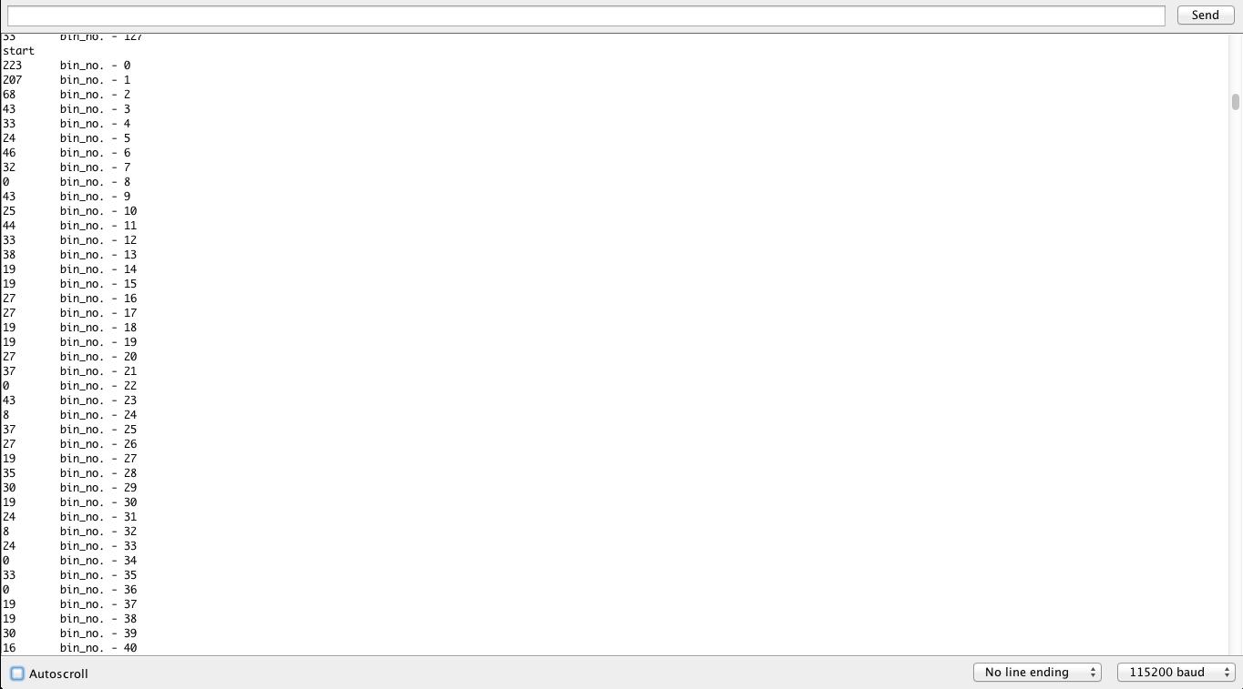

*Figure 4: FFT Serial Monitor output*

4.2 **Wearable Gestures**

The testing of the wearable gestures was done by implementing a circuit that included an RGB LED which was connected to the Photon. The gestures were sent via Bluetooth from the Arduino 101 to Raspberry Pi. The Node JS code running on the node server on the Raspberry Pi, receives the gesture and sends it to the Photon via Bluetooth. The photon receives the signal and performs the necessary action on the LED.

*Figure 5: RGB LED test circuit* 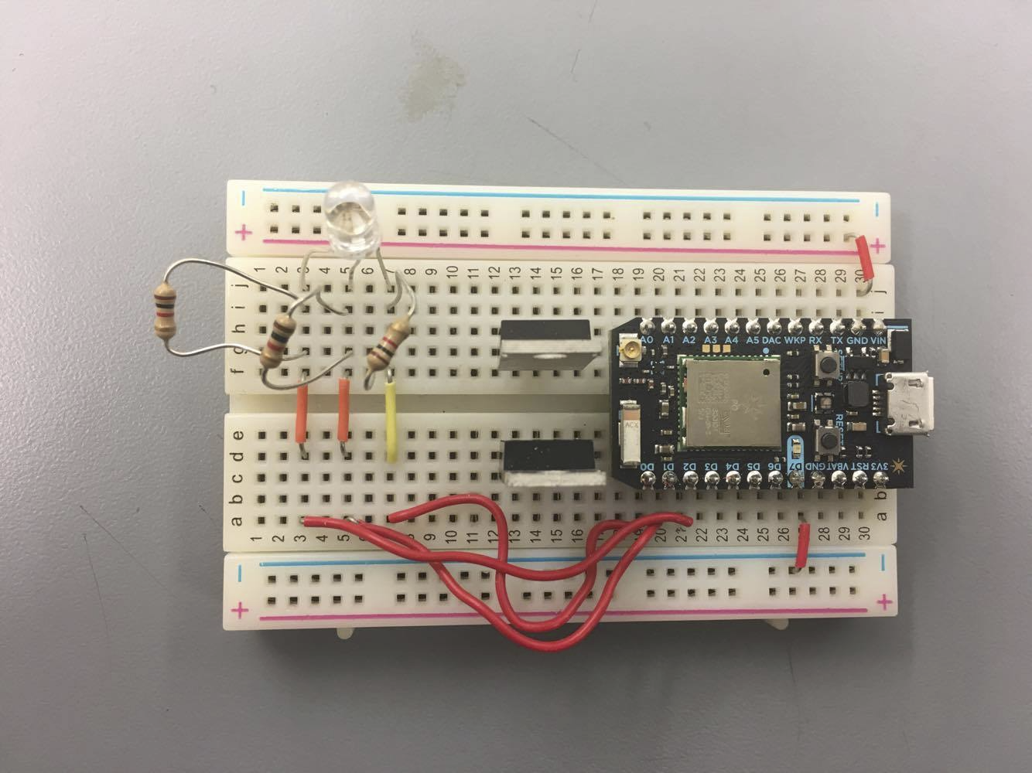

4.3 **Web Application - Gestures**

The web application is able to control the light fixtures using the button as shown in the figure below.

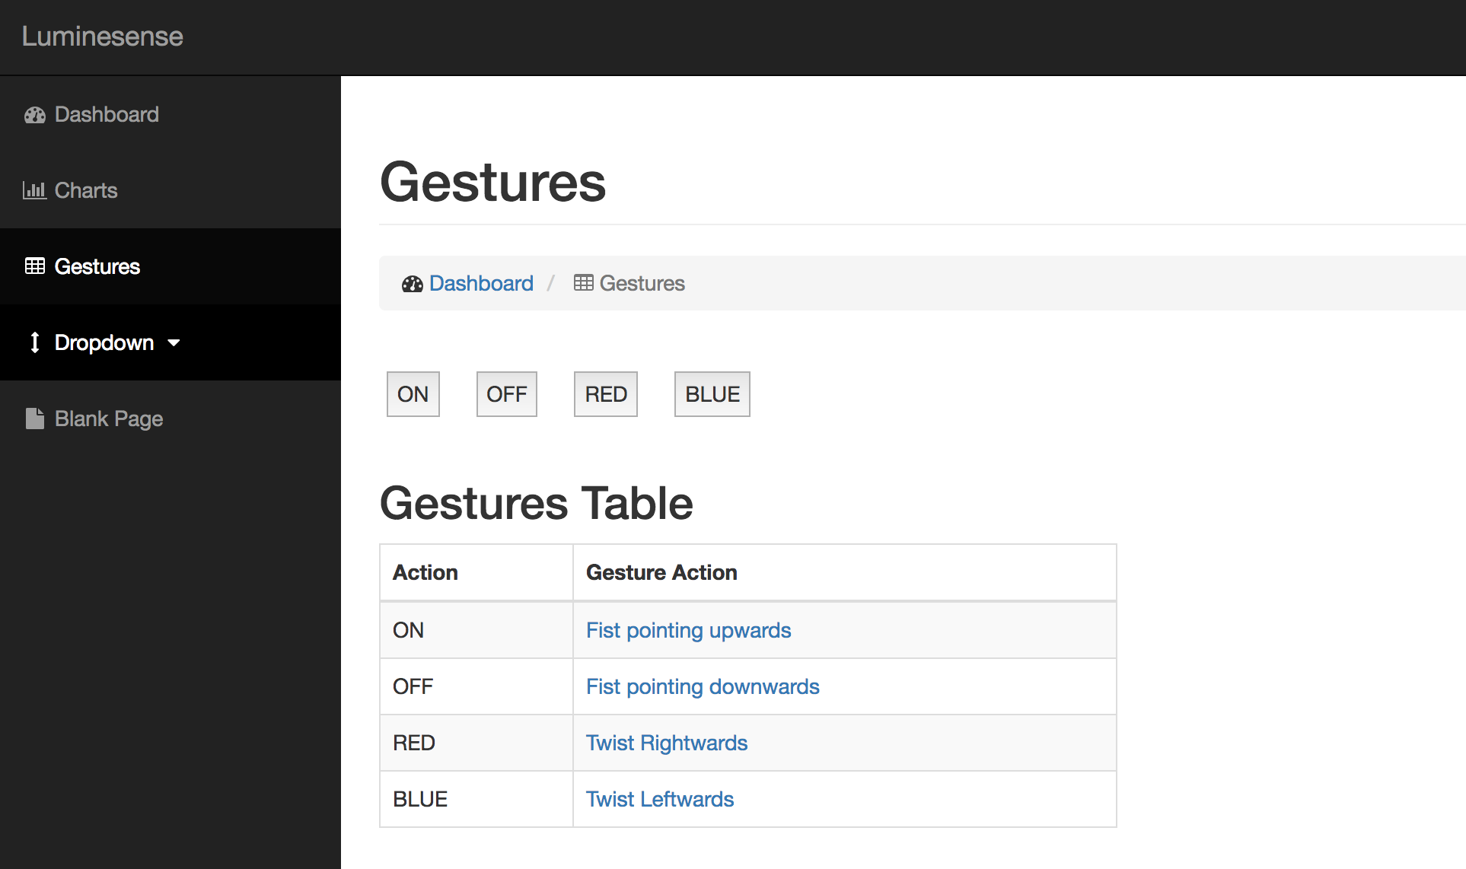

*Figure 6: Gestures User Interface*

4.4 **Web Application - Energy Savings**

The following set of commands are run in the shell in the directory of the web application: 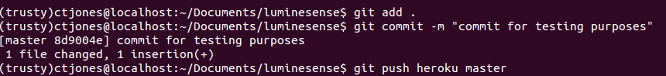

*Figure 7: Shell commands*

This pushes the code to the Heroku repository, and prompts the update of the web application. Then, by navigating to the url of the web application at [https://luminesense-test.Herokuapp.com/](https://luminesense-test.herokuapp.com/) we see the index page of the application, shown below:

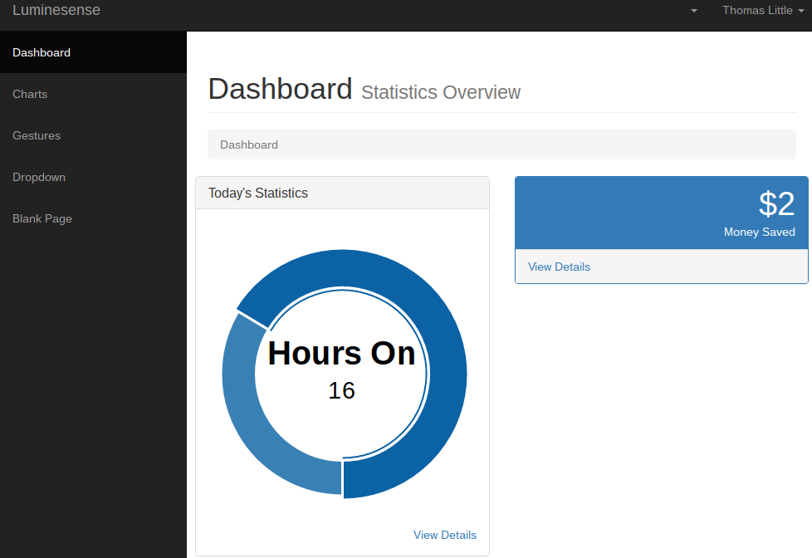

*Figure 8: User dashboard*

This shows successful deployment of the web application and the integration with the cloud. When the web application is updated, it triggers input to the Heroku log files for the web application. By using console.log() print statements in the node.js code, it is possible to see the successful connection to the PostgreSQL database. The Heroku log displaying this is shown below:



*Figure 9: Heroku data logs*

To further show the Heroku cloud and PostgreSQL integration, we can directly connect to the

PostgreSQL database using the PostgreSQL command line interface, shown below:

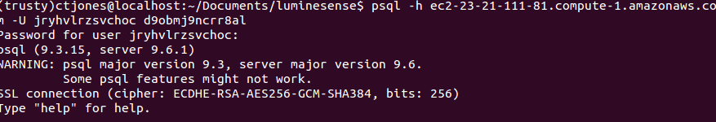

*Figure 10: PostgreSQL CLI*

From the PostgreSQL command line interface, it is also possible inspect tables. Shown below is the inspecting of the time table, which contains the timestamp and integer columns:

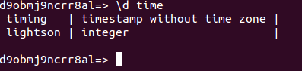

*Figure 11: PostgreSQL table column viewing*

The data from this database is queried for the purpose of populating the graph below, which is on the index of the web application:

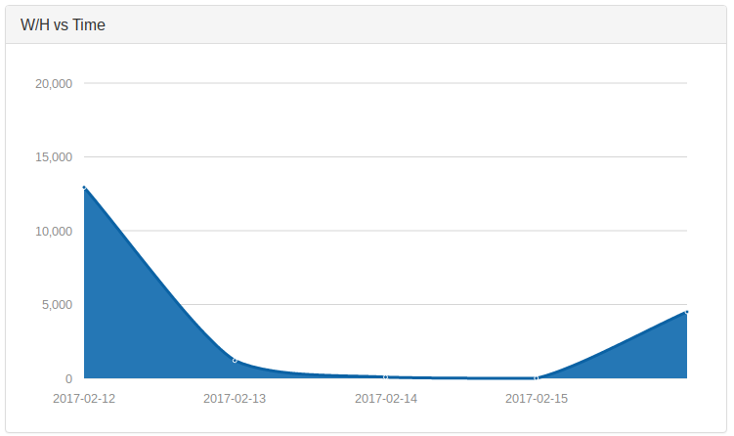

*Figure 12: Chart that maps Watts/hr against Time. The data is pulled from the PostgreSQL database*

This shows the successful deployment of the web application, the ability to populate and query a PostgreSQL database, and the population of data from the database to the web application for a user to view.

4.5 **Wearable Design**

In order to test the battery life on Arduino, fully charge the battery, then connect it to an Arduino and turn on the switch and begin timing. Leave it until the LED light - which indicates battery performance on the battery shield - goes off then stop the timing. The battery life for the battery shield on Arduino is approximately 19 hrs 48 mins.

4.6 **Adaptive Mode**

The following terminal output indicates the successful initialization of the Raspberry Pi drivers

and the sensors. At this point the lights on the single pixel sensors turn off and the data stream becomes available.

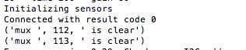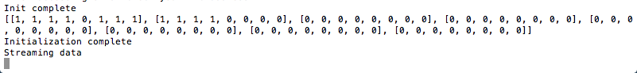

*Figure 13: IR Sensor data stream*

Once the recorder program executes, the following is written in a .txt file

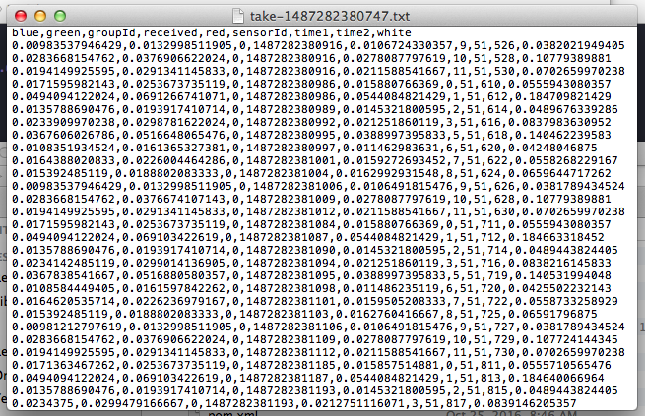

*Figure 14: IR Sensor containing RGBW values and sensor ID’s*

This thermal data is repeatedly sampled for each sensor. Its fluctuations will serve as the basis for adaptive mode. Values for blue, green, red, and white change based on events like a change in light intensity or new occupants.

4.7 **Particle Photon**

During the testing of the Photon, command data was sent from the PC via a CLI call to the Photon’s function (over Wi-fi). The Photon’s code *luminesense_disco.ino*, *luminesense_brighter.ino*, and *luminesense_dimmer.ino* contains functions which changes the luminaire states based on the input commands.The luminaire states were identified by the return value of the call to the functions and by viewing the luminaires themselves. Luminaire state and command data was collected and outputted to the Terminal window as shown below in Figure X.

4.8 **Latency Determination**

With results printed out on the Serial Monitor, it is clear that the delay comes from the IMU data collection. The time interval is calculated by subtracting the 2 timestamps in gesture reception and collection. After several tests, the average delay between gesture performance and IMU data collected is 5 seconds.

**5.0 Conclusions**

5.1 **Light Modulation**

Conditions for a successful test involve an agreement between the modulated lights and the frequencies seen on the oscilloscope and the modulated Photons. This is illustrated below in Figure X.

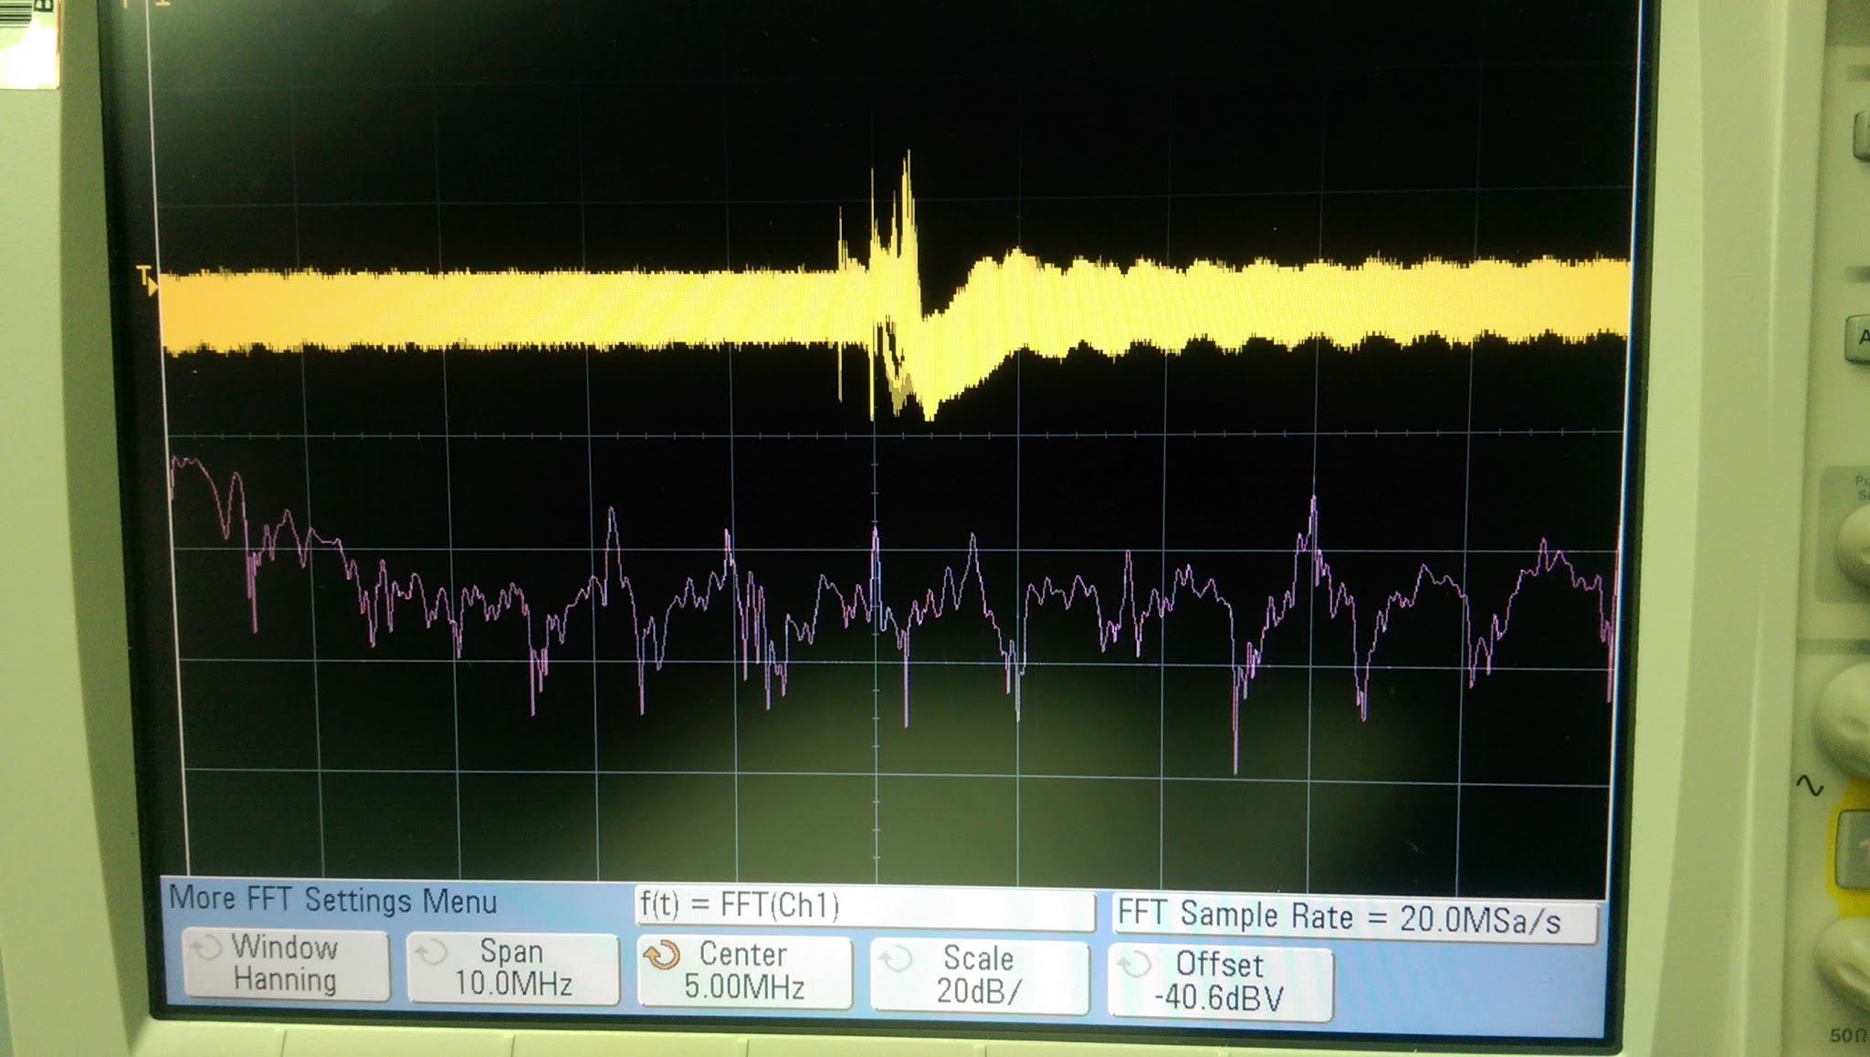

*Figure 15: Oscilloscope readings - Yellow indicates Voltage/Time, Purple represents Amplitude/Frequency, where the peaks represent the frequencies observed by the photodiode*

5.2 **Wearable Gestures**

The new gestures created and tested for the second deliverable allowed the users to control the colors of the light fixtures. This was a key deliverable required by the customer. The next steps would be adding more gestures to add a “disco mode” and ways to dim and brighten the light fixtures.

5.3 **Web Application - Gestures**

For the second deliverable, we started to create the web application that allows the user to look at their monetary savings as well as energy savings in the dashboard. The web application also allows a way for the user to control the light fixtures using buttons and other interfacing tools. Creating a interactive, simple and eye-catching UI is the next key step in terms of web application. The back-end for the communicating with the Raspberry Pi also needs to be worked on.

5.4 **Web Application - Energy Savings**

This second deliverable test showcased an important step towards the construction of a user portal and a significant advancement in the user interactivity with the system. The cloud integration and database integration serves as a foundation for the rest of the web application to be built upon. The next step in expanding on these capabilities will be to populate the database with actual data gathered on the raspberry pi on the system, and to streamline the user experience in order to display the most pertinent data to the user and allow for customizations by the user on the data that they wish to see.

5.5 **Wearable Design**

The battery life is reasonably long for daily use as a wearable device and requires only three hours to charge the battery from zero to fully charged. During the second deliverable test, the battery helps the wearable device in the project to be portable instead of relying on the cable connecting the board to a PC for power.

5.6 **Adaptive Mode**

The deliverable displayed the ability to sample accurate RGB data in real time. This is an important part of adaptive mode, seeing that the system needs to seamlessly adapt and react immediately as users move through the room. The next step in completing the adaptive mode solution will be identifying specific data patterns caused by events that we care about (empty room, somebody walking into the room, user moving through the room, inactivity, etc.) Once these events are mapped out, an algorithm can be implemented to detect these changes in real time and respond by adjusting the luminaires accordingly.

5.7 **Particle Photon**

Conditions for successful testing included agreement between the observed change in state of the luminaire and the code flashed onto the Photon. The code samples are illustrated below. The links to the luminaire demonstrations are included as well.

[**https://drive.google.com/open?id=0BwJYWe7_LAARY0E2bVpvanM0Z00**](https://drive.google.com/open?id=0BwJYWe7_LAARY0E2bVpvanM0Z00)

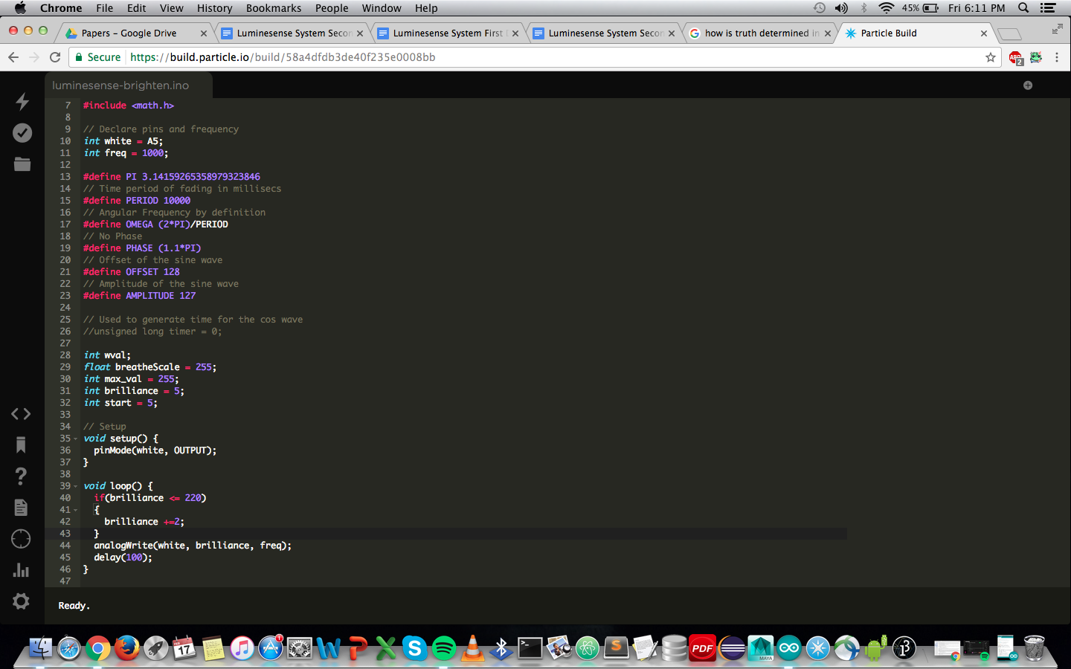

*Figure 16: Brighten command*

[**https://drive.google.com/open?id=0BwJYWe7_LAARRkFPMjhfOVBLTjA**](https://drive.google.com/open?id=0BwJYWe7_LAARRkFPMjhfOVBLTjA)

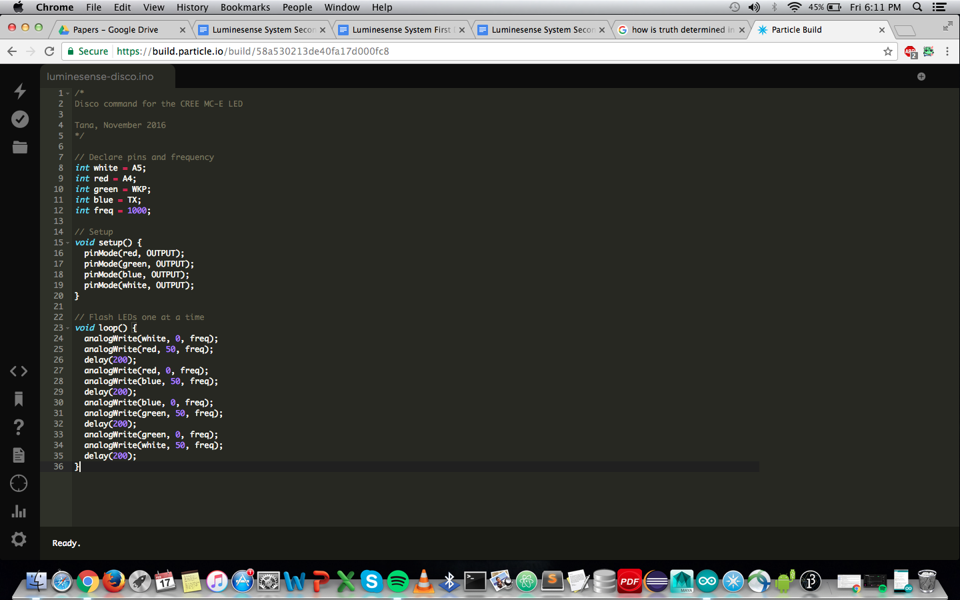

*Figure 17: Disco command*

[**https://drive.google.com/open?id=0BwJYWe7_LAAROGpxSTRkWnhWRVk**](https://drive.google.com/open?id=0BwJYWe7_LAAROGpxSTRkWnhWRVk)

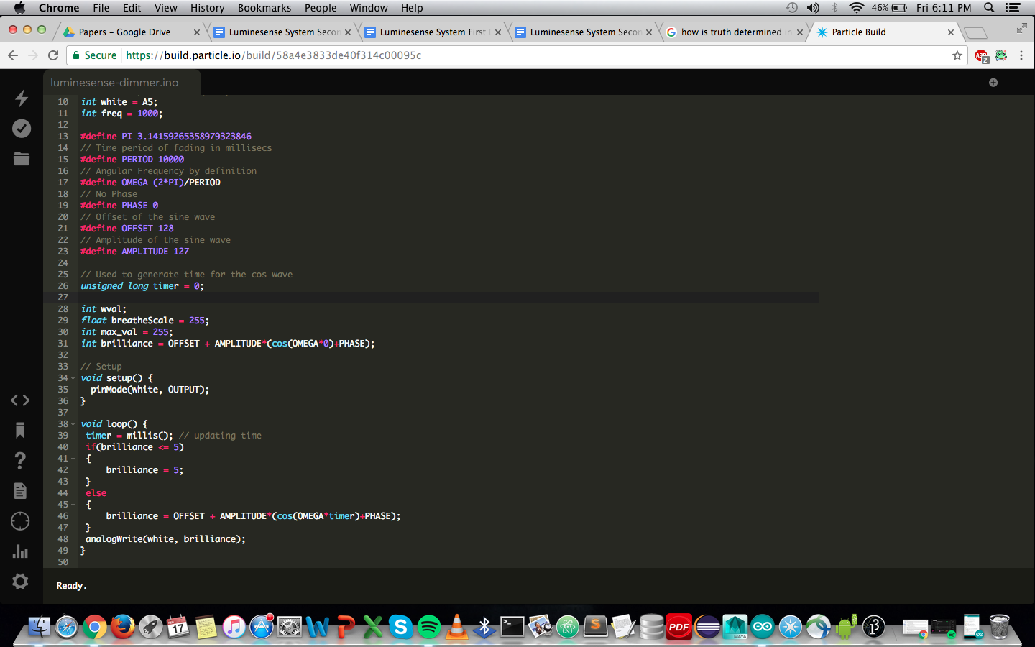

*Figure 18: Dim command*

5.8 **Latency Determination**

After the second deliverable test, the latency is finally confirmed to be caused by the IMU data collection on the Arduino side. This is crucial since more development can be done towards fixing this lagging component. From this test onwards, more focus will be on the Arduino IMU data collection to reduce the delay. The reduction of delay on IMU data collection will be figured out by changing the interrupt that polls for IMU data collection.

5.9 **Coda and Future Work**

The data presented prior to and on the day of testing implies that the implementation of the test design is successful. Future, more complex iterations of the design will build upon the architecture of this design. For example, being able to select and instruct several luminaires, and implementing more gestures. The integration of subsequent design features will be further discussed in future design reviews.